S&H – Puzzle Solution
A | M | R | F | R | B | E | S | F | D | V | X | H | T | B | W | L
P | T | H | O | Z | D | E | A | P | N | I | U | R | X | E | U | Z
U | E | W | Q | S | E | C | H | I | E | G | S | C | H | A | O | E
L | I | N | D | L | I | R | W | W | G | I | O | Q | P | M | N | E
O | I | J | K | A | S | E | W | Y | X | N | H | Y | L | G | I | D
W | H | Z | E | W | V | Q | G | V | L | G | P | U | E | R | T | A
X | O | U | P | N | O | I | T | W | F | W | B | F | S | B | K | F
A | D | Q | T | S | U | K | D | R | E | A | W | M | V | H | O | W
T | B | G | M | C | W | F | L | M | Y | A | N | I | O | N | Z | D
E | R | N | Z | E | H | W | F | K | T | O | U | T | E | L | R | S
U | S | I | A | O | O | N | S | Q | W | D | N | P | O | G | L | J
W | C | P | V | B | T | R | S | R | A | H | Z | I | M | N | Q | y
J | R | Z | M | L | A | D | K | N | G | S | R | S | R | U | I | N
U | F | S | T | T | Q | R | Z | B | W | A | S | C | P | O | T | O
K | N | T | S | P | O | Z | E | W | V | M | N | E | R | V | T | L

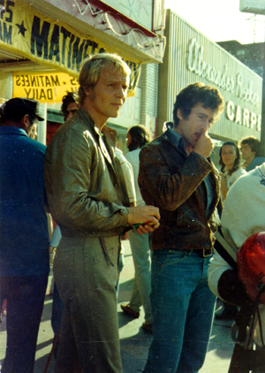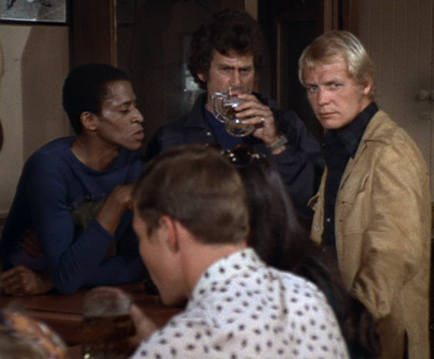
MERRY CHRISTMAS and a Happy New Year
Hutcherie

