Silviabella's Starsky & Hutch Christmas Project

Hello all!

I'm silviabella and today I'll teach you how to make decorations with your own hands for a very Starsky & Hutch Christmas! You can hang them on your Christmas tree or wherever you like.

What you will need:
thin cardboard
a pencil
scissors
a ball of colored wool
glitter
stick glue and vinyl glue
a crochet hook
a stapler
hair-spray
ribbon
Starsky and Hutch's photos!

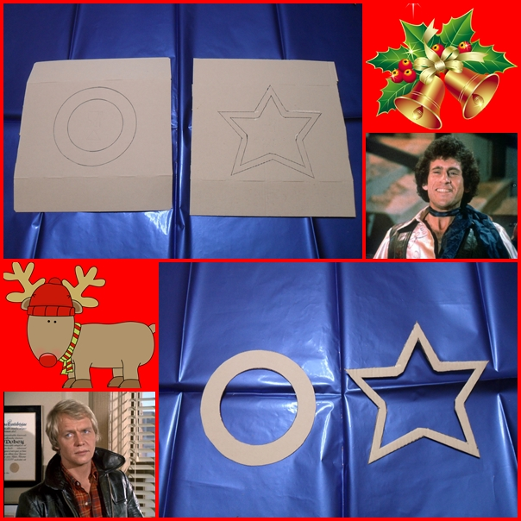
On a piece of thin cardboard, trace out a circle or a star and then a smaller one inside the first one. I used a cup and a glass for the circle, and I draw the star freehand (you don't need to be meticulous, I was not!). Cut it out along the lines so that you have the frame of your decoration.

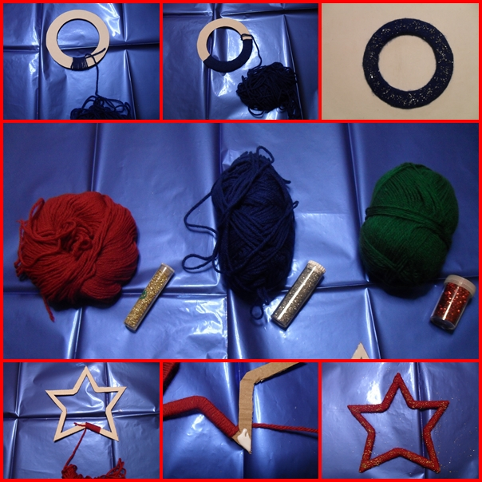
Take a good length of your ball of wool and wrap it around the cardboard, being careful to anchor the end of the thread you wrap. If you make the star-decoration, you need to use the vinyl glue to secure the thread to the edges of the cardboard. You will have a better result if you apply the vinyl glue on the back side of the star. At the end, you have to secure the thread in the back side (you can easily do it with a crochet hook).

Now for the glitter! Spray hair-spray on the yarn and sprinkle the glitter while it's still tacky.

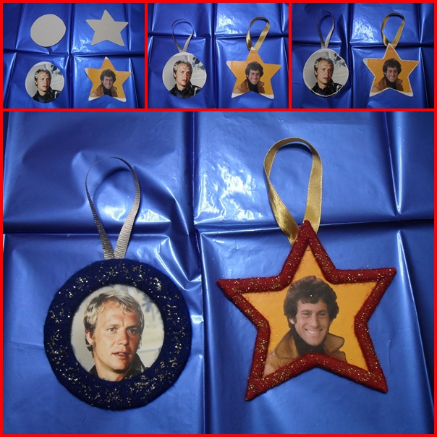
Now trace out one more circle or star about the same size of the first one you drew. Cut it out and paste your picture of the guys on it with the stick glue. Staple a loop of ribbon to the top.

Finally, put vinyl glue on the edges of the picture and place the wool frame on it, pressing well.

Voilà!

